Vy Duong

CSC 470

**The difference between C and another language. Will C still be used in 10 years? Why and why not?**



           C is the middle-level programming language developed between 1969 and 1973. The father of C is Dennis Ritchie. It was originally designed to be used on multiple computers. It is the bridge between machine language and high-level languages. C contains both high-level functionality (used for software applications) and low-level functionality (used for drivers and kernels). C is a structured programming language that allows a program to have functions and let the data move across these functions. C is used for popular systems such as Windows, UNIX, and LINUX. ‘C’ can be considered as a god’s programming language. It is the base for a lot of different languages.

           C is a procedural language. The procedural language solves a problem in terms of a list of instructions. This means that the programming solves the problem steps by steps and does what you need it to do. Compared to Object-Oriented languages, C breaks down to functions while the Object-Oriented language like Java will break down to Objects. C is a compiled language so it will convert the whole code into machine language and run it so the computer can understand the human-like language.

           C can be used for system programming as well as application programming since this is not the same case for a lot of modern programming languages nowadays. However, it does not have an inheritance, which means that it is hard to reuse code. C is not a friendly language for the user, but it has a closer significant to the machine-level code. Memory allocation is done by malloc while in an object-oriented language, it is usually done by the “new” keyword. C supports pointer. It supports a call by value and reference. It supports user-based memory. It follows a top-down approach.

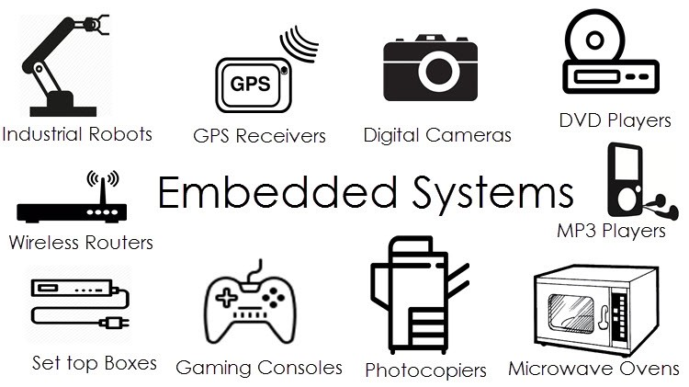           Soon, I think that we will continue to use C because it is the foundation for a lot of operating systems. In 1972, the UNIX operating system was written in C. Oracle changed from assembly to C in 1977. In Windows system, most of the source code is written in C. Linux kernel is also written in C. C was created a long time ago to support those systems back then when there is not a lot of options for programming languages. For that saying, big operating systems such as Microsoft Windows, Linux, Mac, Mobile have most of their code written in C. For that reason, once they change the programming languages, it might be costly especially to big companies. Not only operating, but some databases use C such as Oracle Database, MySQL, MS SQL Server, PostgreSQL. These databases are used in different kinds of systems such as financial, government, media, entertaining,… Some 3D movies used C because it can be very efficient and fast. C can help handle a large amount of data and do calculation so it takes less time for the artists to generate move shots,… C is commonly for embedded Systems. For example, the alarm clock that wakes you up, the microwave, the coffee maker, the remote control,… C are popular go-to programming languages for embedded systems. For those machines, the smaller the operating system, the better it is. For that reason, C is the perfect programming language due to its flexibility, efficiency, performance, and closeness to the hardware. It is costly and hard to get rid of C.

           There are a couple of reasons why C would still be used in the future. First, C is portable and efficient. It is considered as a portable assembly language. Compilers, libraries, and interpreters of other programming languages run with C. Interpreted languages such as Python, Ruby and PHP have their implementation written in C. Second, C is memory manipulation. Memory address access and pointer arithmetic is mostly the reason why C is used for system programming (operating system and embedded system). Computer microcontrollers in hardware/software need to map their peripherals and I/O into memory addresses. Third, C has determined the usage of resources. System programming can not rely on the garbage collection because of its limitation in time and memory resources. They use real-time systems, which can’t afford the garbage collector calls. This situation might lead to a lack of memory. C uses pointers to place data in custom addresses. Fourth, C has a small runtime and the memory footprint for its code is smaller compared to other languages.

           Developers should learn C because it is a lingua franca. Since C is an old and widespread language, knowing the basic concept of C can help the developer understand a wide range of operating systems written in C. Besides, it will help them know about how the embedded system works.

           In conclusion, C is the father of programming languages. Even it is not as good as other modern programming languages, it still widely uses in a lot of aspects of computer systems. The language will be maintained and used in the next 10 years.